City of Oakley
Request for Proposals
For Grant Writing Services

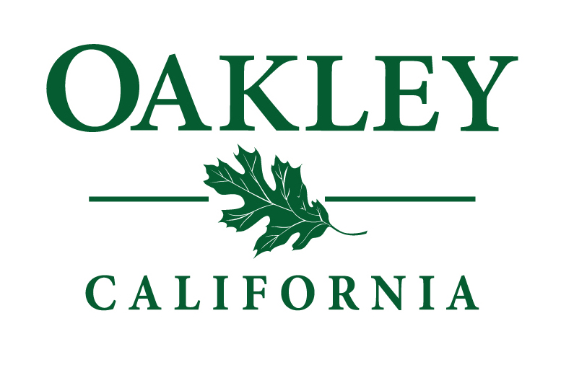

Deborah Sultan,
Finance Director
(925) 625-7010
sultan@ci.oakley.ca.us
City of Oakley
3231 Main Street
Oakley, CA. 94561

INTRODUCTION
The City of Oakley (“City”) invites qualified candidates to submit proposals for contractual grant writing services. The City is seeking to contract with an individual or firm that specializes in the management of the overall grant process and can assist the City to maximize the benefits of grant funding.

BACKGROUND
It is the intention of the City to apply for grants which address documented City needs associated with service delivery and necessary capital infrastructure improvements. In addition, it is the intent of the City to apply for grants which not only are consistent with identified City needs but those grants that can be property and efficiently administered by staff taking into account existing duties and responsibilities. The goal of the City’s grant program is to secure funding for services and projects which the City otherwise would be required to utilize local tax dollars.

Proposal Conditions and Information
Proposals must be received by the City of Oakley by 5:00 p.m. on March 15, 2018. Late proposals will not be considered. The City highly encourages early submission of proposals.

Proposer shall submit one electronic version of the proposal including any supporting documentation addressed as follows:
Deborah Sultan, Finance Director
Email: sultan@ci.oakley.ca.us

The subject line must clearly state:
Proposal Attached – RFP for Grant Writing Services

Questions regarding this proposal must be submitted in writing to Deborah Sultan by March 5, 2018

Scope of Work
The following are typical services and/or items that the successful consultant will be required to provide the City if it is awarded the contract and should be addressed in each proposal.

- Funding needs analysis – Work with the City’s departments to assess the validity of current funding priority areas and identify new priority areas for funding.

- Grant Funding Research – Conduct research to identify grant resources including, but not limited to federal, state, foundation, agencies and organizations that support the City’s funding needs and priorities in the following general areas by way of illustration by not limitation:
  - Community/Economic Development
  - Criminal Justice Technology and Programs
  - Infrastructure Development and Maintenance
  - Parks and Recreation
  - Transportation/Highway /Sustainability/Transit
  - GIS Geographic Information System
  - Community and Municipal Planning

- On-call Grant Research – In addition to the areas defined above other areas may be also identified through the Funding needs analysis process and throughout the duration of the contract.

- Grant proposal Development – Provide grant proposal writing services associated with the completion of grant applications on behalf of the City, including the preparation of funding abstracts, production and submittal of applications to funding sources. A copy of each grant application submitted is to be provided to the City of Oakley.

- Monthly reports – the successful consultant shall submit monthly reports to the City summarizing the amount of time expended and describe activities undertaken during the previous month.

Proposal Requirements
Proposers must submit a detailed proposal which includes, at a minimum, the following:
- Define the methodology/approach to be used to identify the needs of the City which would be eligible for funding through grants, including whether costs will be hourly or per grant written and submitted.

- Detail the procedure you would utilize in identifying grants which would address the needs identified as above.

- Generally, detail the involvement and role of City staff and City resources in the grant writing process. Describe, in detail, the process you would utilize to prepare the actual grant application.

- List your experience in the identification and preparation of grants for municipalities. Specifically, detail your experience with federal and state grants for public safety agencies, infrastructure improvement, parks, recreation, technology community development and capital assets.

- List up to five (5) funded grants which you developed detailing the funding source, amount requested and amount funded.

- Describe the background, experience and qualifications of the person(s) who will act as the grant writer and the qualifications of any staff who will assist with the preparation of grant applications (include their role, education, relevant experience and related qualifications)

- Provide at least three (3) references including the name of contact, affiliation, address, direct telephone number and email address.

- Describe in detail the fee structure you propose for providing grant writing services.

Selection
City will make its selection based on its review of the proposals submitted. The criteria will include qualifications, experience, fee structure, ability to meet the needs of the City.

The City of Oakley reserves the right to reject any or all the proposals, to waive informalities in the proposals or the proposal process. The City may interview selected proposer. The City of Oakley further reserves the right to award the contract to other than the lowest proposer if such action is deemed to be in the best interest of the City.

Insurance Requirements
All vendors, companies and individuals shall procure and maintain during the term of the contract the following insurance policies:
- General Liability

- Automobile Liability

- Workers Compensation & Employers Liability

- Professional Liability and Errors and Omissions

