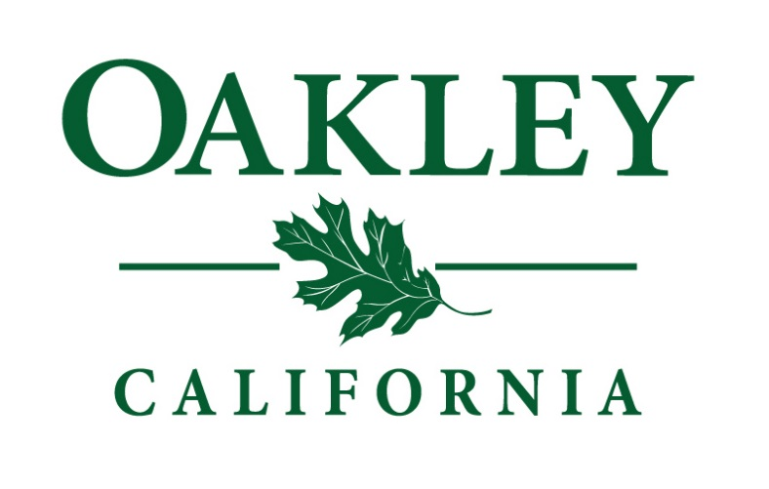

City of
Oakley
Economic 2016 - 2017
Development
Work Plan

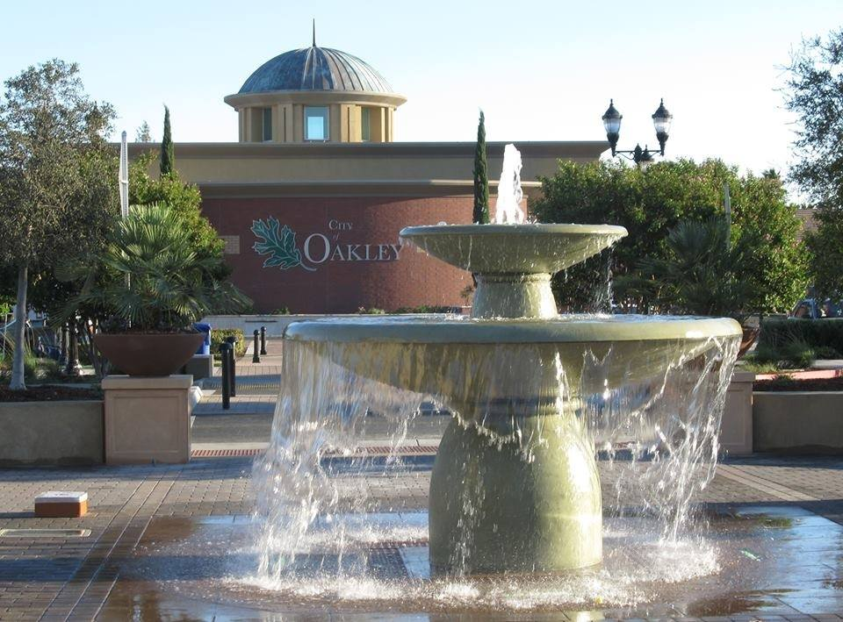

Executive Summary

The City of Oakley has experienced steady growth since its incorporation in 1999 and many steps have been taken to help with the overall economic development of the community. Along with the dozens and dozens of capital projects and other programs to foster economic development over the last 16 years, there have been some specific policy documents developed: In 2002, the City adopted an Economic Development General Plan Element; In 2009, the City completed an Economic Development Assessment; and in 2010, the City adopted an Economic Development Work Plan.
In 2014, the City hired a full-time Economic Development Manager and created a 2014 – 2015 Economic Development Work Plan. As Oakley has continued to grow and develop, an updated 2016 – 2017 Work Plan is needed to meet the current needs of the community and businesses in Oakley.
The Work Plan Goals are shown as follows:
- Prepare the City of Oakley to be a competitive location for the attraction of new business opportunities and investment in the community
- Update the City marketing program
- Facilitate new business opportunities and new investment in the community
- Provide tools and resources to help existing Oakley businesses grow and succeed
- Improve the look and feel of the Downtown and Main Street corridor while maintaining its small town character

Goals

Prepare the City of Oakley to be a competitive location for the attraction of new business opportunities and investment in the community

Update the City marketing program

Facilitate new business opportunities and new investment in the community

Provide tools and resources to help existing Oakley businesses grow and succeed

Improve the look and feel of the Downtown and Main Street corridor while maintaining its small town character

Goal # 1
Prepare the City of Oakley to be a competitive location for the attraction of new businesses and new investment

A proactive approach to Economic Development involves laying the groundwork to prepare for the attraction of new businesses and new investment in the community. The first step in this process involves identifying sites that have the most potential for new development or for the expansion/location of existing businesses. Maintaining an inventory and marketing these sites will allow for increased visibility from the development and business community.

- Implementation Elements
  - Update and maintain the inventory of sites for new development listed on OppSites

  - Identify and maintain an inventory of vacant commercial space available for expansion/location on the Economic Development web page

  - Partner with Building, Planning & Code Enforcement to coordinate and streamline development and permit activities

Goal # 2
Update the City marketing program

With the continuing work of preparing the City to be a competitive location, an ongoing marketing program is needed to “spread the word” of Oakley as a desirable location for new businesses and new investment. The marketing program will be updated to highlight Oakley’s advantages through printed materials and on the Economic Development webpage.

- Implementation Elements
  - Update printed materials that promote the City to new investment. Materials to include the following:
    - City promotional piece
    - Demographics
    - Traffic Counts
    - Residential Development Activity

  - Update the Economic Development pages on the City’s website

Goal # 3
Facilitate new business opportunities and new investment in the community

Attracting new development and new businesses to the City is a key component of any Economic Development program. Preparing the City (Goal #1) and marketing the City (Goal #2) will pave the way for success in attracting new businesses and investment. Attraction activities center on the land that will be developed or the existing buildings that will house a new business/tenant. Identifying real estate with the most potential involves outreaching and developing relationships with realistic and motivated property owners. In addition, outreach and relationships with the development and brokerage community is a key component for attraction efforts.
- Implementation Elements
  - Identify real estate with most development potential

  - Identify, develop and strengthen relationships with realistic and motivated property owners

  - Further develop outreach efforts to development and brokerage community through semi-annual luncheons

  - Partner with Claremont Companies to further new investment on the former DuPont property

  - Partner with regional organizations/initiatives including East Bay EDA and the East Bay Leadership Council

  - Contact prospective retailers through “cold calls” on a monthly basis
Goal # 4
Provide tools and resources to help existing Oakley businesses grow and succeed

A majority of new jobs created in a community comes from the expansion of existing businesses. Providing the tools and resources that existing Oakley businesses need to grow and expand is crucial to the Economic Development effort.

- Implementation Elements
  - Enhance relationships with the business community through:
    - Annual business survey
    - Company visit outreach program – Oakley VIB (Very Important Business)

  - Continue to strengthen the partnership with Oakley Chamber of Commerce

  - Provide tools to promote local businesses through the “Shop Oakley” campaign, Oakley business coupon book, and local fishing tournaments

  - Continue to implement and expand the Oakley Entrepreneur Development Program
    - Establish the Oakley Entrepreneur Incubator space and associated programs
    - 11-week Entrepreneur Business Plan Training class
    - Semi-Annual Entrepreneur Training class business plan follow-up

Goal # 5
Improve the look and feel of the Downtown and Main Street corridor while maintaining its small town character

The “look and feel” or “sense of place” are key elements that the Economic Development program will work to convey in its attraction efforts. As Oakley continues to grow as a new city, the Downtown and Main Street corridors are key to conveying the image and vision that Oakley is working towards. Attracting new investment to the City and retaining existing businesses is linked to the image that the City conveys. Economic Development efforts will work to improve the look and feel of Downtown and the Main Street corridor, while still maintaining the small town character that Oakley does not want to lose in the push for new growth.

- Implementation Elements
  - Continue to promote the Downtown Revitalization Loan Program to facilitate building renovations in the downtown area

  - Identify and outreach to possible entities that could create events in the downtown that engage and meet the needs of the community and promote local businesses

  - Partner with the Planning Department to identify and capitalize on opportunities that could be realized from the anticipated train platform in Downtown

  - Facilitate in bringing an upscale coffee and other “mom and pop” type of shops to Downtown

