NON-PROFIT GRANT
APPLICATION

CITY OF OAKLEY, CA

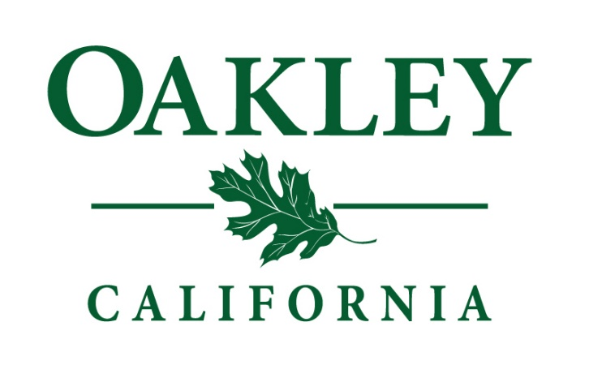

ISSUE DATE: April 11, 2022

DEADLINE FOR SUBMISSIONS: May 19, 2022, 12 PM

Introduction
The City of Oakley (herein referred to as “City”) is pleased to announce the availability of grant funding for local nonprofits through the American Rescue Plan Act (ARPA) Coronavirus State and Local Fiscal Recovery Funds (SLFRF).
The City is accepting Grant Applications from registered nonprofits for projects that meet the objectives of the American Rescue Plan Act SLFRF and are aligned with the City’s goals and priorities.
Background
The City of Oakley has a total of $180,000 set aside to support local nonprofits serving Oakley residents and/or businesses through their work. The maximum award of this one-time grant is $15,000.

The City of Oakley is committed to investing these funds in projects that:
• Align to strategic priorities and address community needs
• Support equitable outcomes for most impacted populations
• Leverage and align with other funding sources
• Make the best use of this one-time infusion of resources
• Have a lasting impact
In ensuring that we are broadly supporting our community through these funds, we provide the following information to help nonprofits determine their potential eligibility and outline the process, funding amounts, and funding requirements.
ARPA State and Fiscal Recovery Funds Overview
On March 11, 2021, President Biden signed the 1.9 trillion dollar American Rescue Plan Act of 2021 to address the COVID-19 pandemic and the corresponding economic crisis. The American Rescue Plan established the Coronavirus State and Local Fiscal Recovery Funds, which allocated $350 billion in emergency funding for eligible state, local, territorial, and Tribal governments to support their response to and recovery from the COVID-19 public health emergency.
The Coronavirus State and Local Fiscal Recovery Funds are designed to bolster agencies’ responses to the COVID-19 pandemic and its economic impacts by supporting the immediate pandemic response, bringing back jobs, and laying the groundwork for a strong and equitable recovery.
The City of Oakley received $10,177,000 in funding, and the City Council has set aside $180,000 to support local nonprofits.
The Coronavirus State and Local Fiscal Recovery Funds may only be used as outlined in the Final Rule and Compliance and Reporting Guidance issued by the U.S. Treasury Department.

Tentative Timeline

Date | Activity
April 11, 2022 | Grant Application Released
April 21, 2022 | Informational Session
May 19, 2022 | Deadline for Submitting GRANT APPLICATION (4 p.m.)
May 23 - June 3, 2022 | Review and Evaluation Process
June 14, 2022 | Recommendations Presented to the City Council

Questions or Technical Assistance
General assistance is available upon request through Tuesday, May 17, 2022, by noon (PDT).

All questions and requests for technical assistance concerning the Grant Application are to be directed to the official contact person via email or mail:

Email: escover@ci.oakley.ca.us

Mail:
Attn: Felicia Escover
Assistant to the City Manager
City of Oakley
3231 Main Street
Oakley, CA 94561

Eligibility and Proposal Requirements
All applicants must meet eligibility and submit the required information to be considered for a funding recommendation. To be considered for funding, applicants must:
- Submit a complete and responsive application
- Be a 501(c)3 nonprofit organization with recognized legal status equal under the United States Internal Revenue Code
- Serve Oakley residents or businesses through their services or programs
- Have up-to-date filings (business license, taxes, etc.)
- Capable of administering grant funds in compliance with federal funding guidelines
- Agree to the terms outlined in the “Grant Agreement Template”

Each proposal shall include the following information:
- Application form, containing:
  - General Information
    - Name of Project/Program
    - Name of Organization
    - Organization’s Address
    - Primary Contact Name, Title, Email, Phone Number
    - Mission Statement
  - Project Description
    - Amount of Funds Requested (up to $15,000)
    - Briefly describe the program/project you are requesting funds for.
    - Have you received other COVID-19 relief funding related to this program or project?
  - Community Benefits
    - Describe the need for the program/project you’re proposing.
    - What populations will benefit from the proposed project and how? How many individuals, families, or other populations be served by this program/project?
    - Describe 2-3 anticipated measurable outcomes for your proposed project/program.
  - Budget Narrative & Organizational Capacity
    - Briefly explain project revenues and expenses related to this proposal. Please summarize major costs and other sources of revenue, including matching funds, if applicable. This should match the figures in the Budget Attachment. (Note: matching funds are not required.)
    - Will you be able to leverage the grant funds to expand the impact of ARPA funds?
    - Describe your entity’s experience and capacity to manage, implement, measure, and report on grant deliverables and use of funds.
- Budget attachment
- Verification of 501(c)3 status

Selection Process and Criteria
An ad-hoc committee, consisting of members of the City Council, will review and score submitted proposals and make recommendations for Council's consideration. After Council's approval, the selected non-profit organizations will enter into a contractual agreement with the City of Oakley and receive funding to execute their program proposal.
In addition to following the criteria set forth by the Secretary of the Treasury, the City may consider, at minimum, the following criteria:
- Tangible Impact: Project has a significant direct benefit to a majority of Oakley residents or businesses
- Long-Term Impact: Project will have impacts on the City or residents/businesses that are long-term in nature.
- Community Need: Project reaches a population of disproportionate impact and responds to a salient community need.
- Alignment: Project is aligned with the City’s strategic plan goals.
- Leveraging: Project leverages a greater than 1:1 matching funds ratio to expand the impact of ARPA funds.
- Efficiency: The project impact is far greater than the resource expenditure.
- Transformative Change: This project would not be possible without ARPA funds.
- Organizational Capacity: The nonprofit has the capacity and experience delivering project deliverables and managing grant funds.
Proposal Submission Information
One original of the proposal must be submitted and received by no later than noon on Thursday, May 19, 2022, to:

Felicia Escover
Assistant to the City Manager
City of Oakley
3231 Main Street
Oakley, CA 94561

An electronic version of the proposal in portable document format (.pdf) must also be submitted before the same time, noon on Thursday, May 19, 2022, by email to:

escover@ci.oakley.ca.us

Proposals received after this deadline will not be accepted. Early submissions are recommended and encouraged. The City reserves the right to reject any and all proposals submitted, request clarification of services submitted, request additional information from competitors, and waive any irregularity in the proposal.

Terms and Conditions
- All responses to this Grant Application become the property of the City and, as such, may be subject to the Public Records Act.
- Any costs and expenses incurred by an organization in preparing or submitting responses are the sole responsibility of the respondent.
- This Grant Application does not commit the City to award funds or fund proposals at the requested level.
- The City reserves the right to request additional information and clarification from any respondents to this Grant Application, including references.
- A respondent must be prepared to present evidence to their responses to satisfactorily meet the requirements set forth or implied in the Grant Application.
- Respondents may be asked to attend a meeting or be interviewed to provide further explanation to the City’s Grant Application Evaluation Committee.
- Respondents agree there is an expectation that quantitative and qualitative information may be required on an as-needed basis for reporting requirements.
- All respondents to the Grant Application must conform to instructions. Failure to include required signatures, meet deadlines, answer all questions, follow the required format, or failure to comply with other requirements of the Grant Application may be considered cause for rejection of the response. All communication must be done through the Assistant to the City Manager. Proposers who initiate private contact with Evaluation Committee Members or attempt to violate the process may be disqualified.

